# Index Table

|  |  |
| --- | --- |
| S. No. | Program Name |
| 1 | Write a C program to enter the radius of a circle and find its diameter, circumference, and area. |
| 2 | Write a program to input five numbers (integer numbers) and find out their average. |
| 3 | Write a C program to input any character and check whether it is alphabet, digit, or special character. |
| 4 | Write a C program to find the sum of all odd numbers between 1 to n. |
| 5 | Write a C program to check whether a number is a Prime number or not. |
| 6 | Write a C program to print a right triangle star pattern. |
| 7 | Write a C program to sort array elements in ascending or descending order. |

List of experiment

|  |  |
| --- | --- |
| 1 | Write a C program to enter the radius of a circle and find its diameter, circumference, and area. |
| 2 | Write a program to input five numbers (integer numbers) and find out their average. |
| 3 | Write a C program to input any character and check whether it is alphabet, digit, or special character. |
| 4 | Write a C program to find the sum of all odd numbers between 1 to n. |
| 5 | Write a C program to check whether a number is a Prime number or not. |
| 6 | Write a C program to print a right triangle star pattern. |
| 7 | Write a C program to sort array elements in ascending or descending order. |

|  |
| --- |
| 1. Write a C program to enter the radius of a circle and find its diameter, circumference, and area. |

|  |
| --- |
|  |

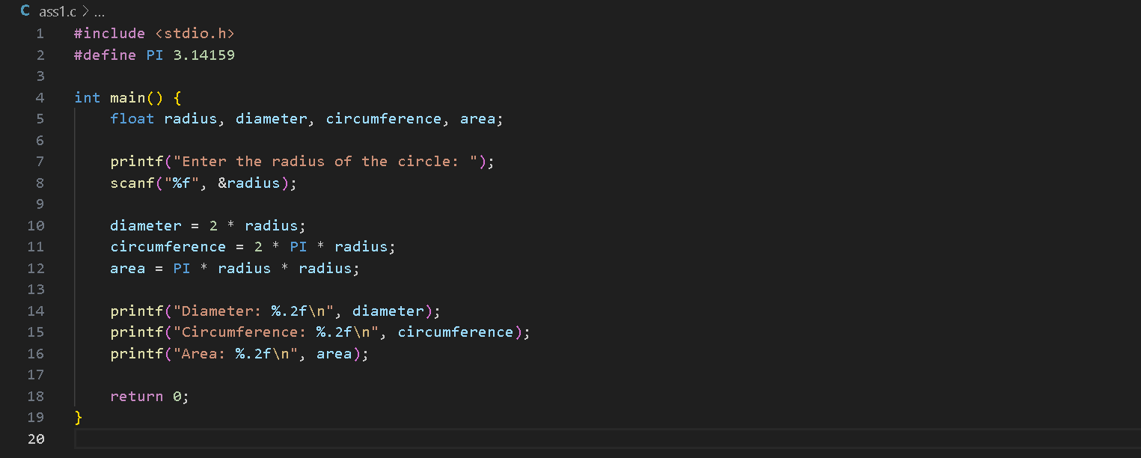

1. Write a program to input five numbers (integer numbers) and find out their average.

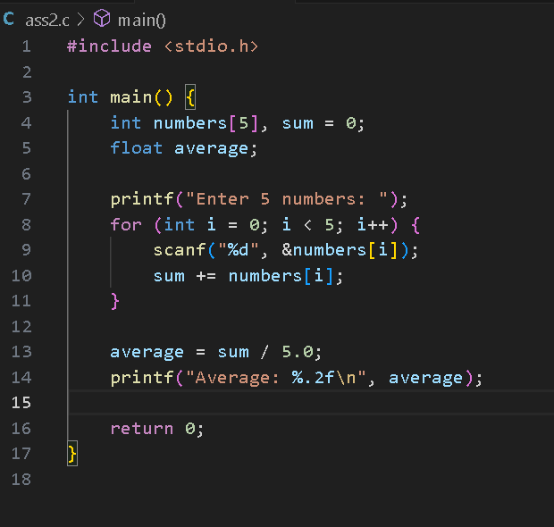

1. Write a C program to input any character and check whether it is alphabet, digit, or special character.

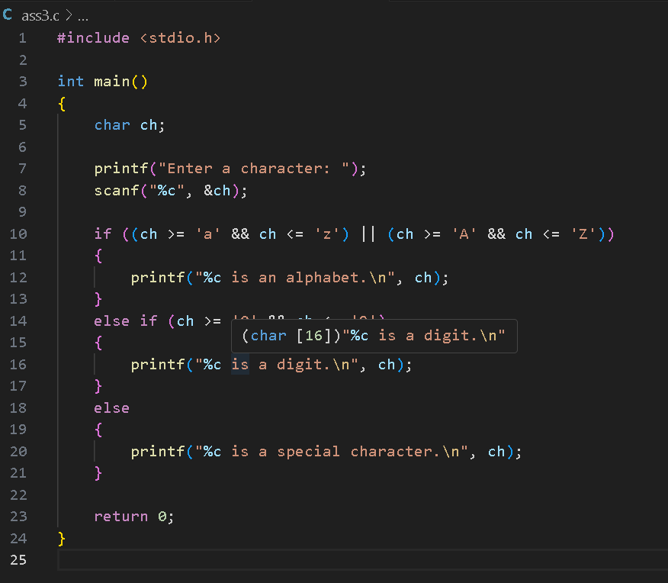

1. Write a C program to find the sum of all odd numbers between 1 to n.

1. Write a C program to check whether a number is a Prime number or not.

1. Write a C program to print a right triangle star pattern.

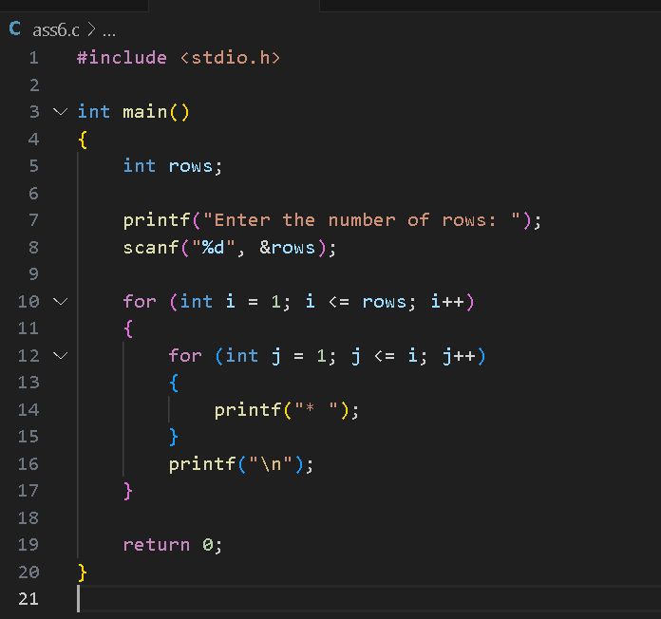

1. Write a C program to sort array elements in ascending or descending orderA screen shot of a computer program

   Description automatically generated

